Software Requirement Specification Of Ticket Vendor Machine

Introduction

1.1 Purpose :
This document provides a comprehensive description of the requirements for the Ticket Vendor Machine (TVM) system. It is intended for developers, testers, stakeholders, and system designers to understand and implement the system effectively.

1.2 Scope :
The TVM system allows passengers to purchase tickets through a self-service kiosk. The system supports destination selection, ticket price calculation, payment processing via external systems, and ticket printing with a barcode.

1.3 Languages :
- Vietnamese (default)
- English

1.4 Stakeholder:
- Passengers (End Users)
- System Operators
- Development Team
- Payment Gateway Provider
- Banking System

Overall Description

2.1 Product Perspective
The TVM is a standalone embedded system integrated with external payment services such as a Payment Gateway and Bank System.

2.2 User Characteristics
- General public users
- No technical background required
- Basic interaction with touchscreen interface

2.3 Assumptions and Dependencies
- Stable internet connection is available
- Payment Gateway and Bank systems are operational
- Hardware components (printer, screen, card reader) function correctly

Process Flow

Ticket Purchase Flow | Payment Integration Flow
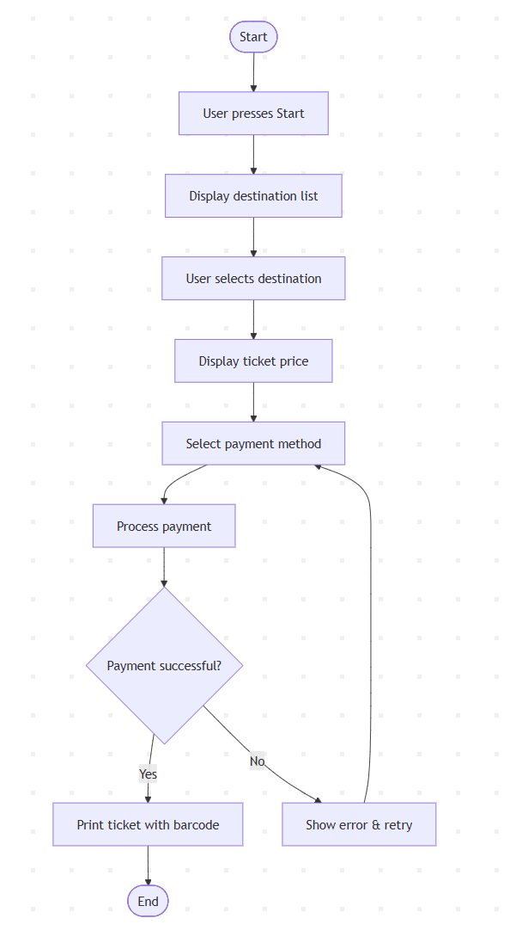 | 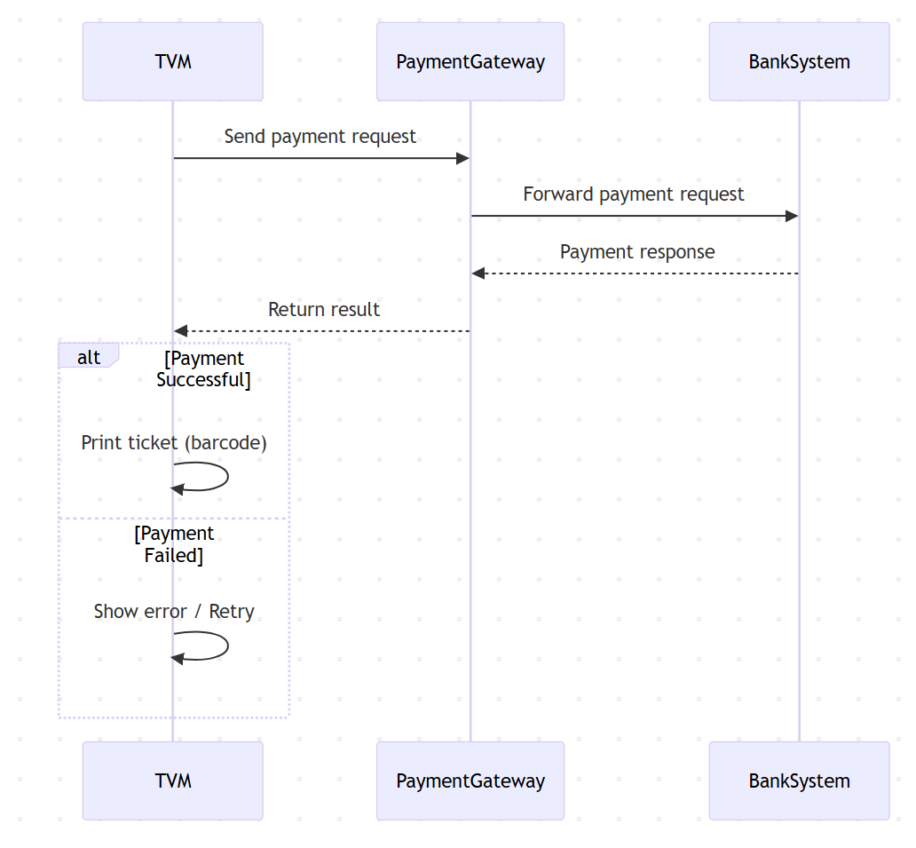

Domain & Integration Rules

4.1. Ticketing Rules

Rule_ID | Requirement | Exception/Note
TVM_01 | The system shall operate continuously (24/7) | If network connection is lost, the system shall display an error message and disable payment processing
TVM_02 | The system shall require users to select a destination before proceeding to payment. | If no destination is selected, the system shall prevent payment initiation
TVM_03 | The system shall display the ticket price immediately after a destination is selected | The system shall not allow users to modify the ticket price
TVM_04 | The system shall limit each transaction to a maximum of 5 tickets | If the limit is exceeded, the system shall display an error and require user adjustment or cancellation

4.2. Payment Rules

Rule_ID | Requirement | Exception/Note
PAY_01 | The system shall support payment via QR Code | Cash payment shall not be supported
PAY_02 | The system shall generate a QR code valid for 60 seconds. | If expired, the system shall require regeneration of a new QR code
PAY_03 | The system shall only proceed to ticket issuance after successful payment confirmation
PAY_04 | The system shall display a failure message if payment is unsuccessful | The user shall be allowed to retry up to 3 times
PAY_05 | The system shall cancel the transaction if no payment is completed within 60 seconds

4.3 . Error Handling Rules

Rule_ID | Requirement | Exception/Note
ERR_01 | The system shall display an error message when payment fails | The user shall be allowed to retry the payment process
ERR_02 | The system shall initiate a refund if an error occurs during ticket printing | The refund shall be processed within 1 minute.
ERR_03 | The system shall disable transactions when there is no network connection | The system shall display a network error message

4.4. Transaction Rules

Rule_ID | Requirement | Exception/Note
TRX_01 | The system shall store all transaction records in internal storage | Failed transactions shall also be recorded
TRX_02 | The system shall generate a unique QR code for each ticket
TRX_03 | The system shall ensure each ticket is valid for single use only | Tickets shall be validated at entry points

5. Functional Requirements

FR_01: Start Transaction
Actor: Passenger
Description:
The system allows the user to initiate a new ticket purchasing session.
Pre-condition:
- The system is in idle state
- No active transaction is in progress
Main Flow:
- The system displays the idle screen with a "Start" button.
- The user presses the "Start" button.
- The system initializes a new transaction session.
- The system navigates to the destination selection screen.
Post-condition:
- A new transaction session is created

FR_02: Display Destination List
Actor: System
Description:
The system displays all available destinations for ticket selection.
Main Flow:
- The system retrieves destination data from local storage or backend service.
- The system displays:
- Destination name
- Route/zone (if applicable)
- The system enables selection for each destination.
Business Rules:
- Only active destinations shall be displayed
- Destinations must be sorted logically (e.g., alphabetical or route order)

FR_03: Select Destination
Actor: Passenger
Description:
The user selects a destination for ticket purchase.
Main Flow:
- The user selects a destination from the list.
- The system captures the selected destination.
- The system stores the selection in the current transaction.
- The system proceeds to price calculation.
Validation:
- A destination must be selected before proceeding

FR-04: Display Ticket Price
Actor: System
Description:
The system calculates and displays the ticket price.
Main Flow:
- The system determines fare based on:
- Selected destination
- Pricing rules (distance between zones etc.)
- The system displays:
- Ticket price
- Currency
- The system enables users to continue to pay.
Business Rules:
- Price must be retrieved from a predefined pricing table
- Price must be consistent with fare policy

FR_05: Select Payment Method
Actor: Passenger
Description:
The system allows the user to choose a payment method.
Main Flow:
- The system displays available payment methods: QR Code ( Momo, VnPay)
- The user selects a payment method.
- The system stores the selected method.
- The system proceeds to payment processing.
Validation:
- A payment method must be selected

FR_06: Process Payment
Actor: System / Payment Gateway / Bank System
Description:
The system processes the payment through external services.
Pre-condition:
- Destination and payment method are selected
Main Flow:
- The system creates a payment request containing:
- Transaction ID
- Amount
- Payment method
- The system sends requests to Payment Gateway.
- The Payment Gateway forwards the request to the Bank System.
- The Bank System processes the payment.
- The Bank System returns response: Success / Failure
- The Payment Gateway returns results to the system.
Alternate Flow (Failure):
- If timeout occurs → retry up to N times
- If payment fails → return failure status
Business Rules:
- Each transaction must have a unique ID
- Payment request must be encrypted
- Timeout threshold: 120 seconds

FR_07: Handle Payment Result
Actor: System
Description:
The system handles the response from the payment process.
Main Flow (Success):
- The system receives a successful response.
- The system updates transaction status = “Successful”.
- The system proceeds to ticket printing.
Alternate Flow (Failure):
- The system receives a failure response.
- The system displays an error message: "Payment Failed. Please try again."
- The system allows users to retry payment.
Business Rules:
- Maximum retry attempts 3 times
- After max retries → cancel transaction

FR_08: Print Ticket
Actor: System
Description:
The system prints a ticket after successful payment.
Pre-condition:
- Payment must be successful
Main Flow:
- The system generates ticket data:
- Ticket ID
- Destination
- Price
- Timestamp
- Barcode
- The system sends a print command to the printer.
- The printer prints the ticket.
- The system confirms print success.
Alternate Flow (Printer Error):
- If printing fails:
- Display error message
- Notify maintenance system (optional)
Business Rules:
- Barcode must be unique
- Ticket must be printed within 5 seconds

FR_09: End Transaction
Actor: System
Description:
The system completes the transaction and resets to idle state.
Main Flow:
- The system displays confirmation message: "Transaction Completed"
- The system clears transaction data.
- The system returns to idle screen.
Post-condition:
- System is ready for next user

6. Non-Functional Requirements
Type | ID | Requirement | Description
Performance Requirements | NFR-01 | System Response Time | The system shall respond to any user interaction within ≤ 2 seconds under normal operating conditions
 | NFR-02 | Payment Processing Time | The system shall complete payment processing (including communication with Payment Gateway and Bank System) within ≤ 5 seconds in 95% of transactions
 | NFR-03 | Ticket Printing Time | The system shall print the ticket within ≤ 5 seconds after receiving a successful payment response.
Reliability Requirements | NFR-04 | System Availability | The system shall achieve ≥ 99% uptime during operational hours.
 | NFR-05 | Transaction Integrity | The system shall ensure that each transaction is processed exactly once (no duplicate charges)
 | NFR-06 | Fault Recovery | In case of system failure (e.g., power loss), the system shall be able to:  - Recover incomplete transactions  - Prevent duplicate ticket issuance
Security Requirements | NFR-07 | Data Encryption | All communication between TVM, Payment Gateway, and Bank System shall use HTTPS/TLS encryption
 | NFR-08 | Sensitive Data Protection | The system shall not store sensitive payment data such as:  - Account number
 | NFR-09 | Authentication & Authorization | External systems (Payment Gateway, Bank System) shall be authenticated using secure API mechanisms (e.g., API keys, tokens).
Usability Requirements | NFR-10 | Ease of Use | The system shall provide a simple and intuitive interface suitable for general public users.
 | NFR-11 | Interaction Design | All actions shall be completed within ≤ 5 user steps (from start to payment).
 | NFR-12 | Error Feedback | The system shall display clear and understandable error messages when issues occur.
Availability Requirements | NFR-13 | Operating Time | The system shall operate 24/7, except for scheduled maintenance.
 | NFR-14 | Maintenance Window | Scheduled maintenance shall not exceed 2 hours per week
Scalability Requirements | NFR-15 | Concurrent Usage | The system shall handle multiple independent machines operating simultaneously without performance degradation.
 | NFR-16 | Transaction Load | The system shall support at least 1000 transactions per day per machine
Maintainability Requirements | NFR-17 | Modularity | The system shall be designed using modular architecture to allow easy updates and maintenance.
 | NFR-18 | Logging | The system shall log:  - Transactions  - Errors  - Payment responses
 | FR-19 | Monitoring | The system shall allow monitoring of:  - System status  - Hardware status (printer, network)
Compatibility Requirements | NFR-20 | Hardware Compatibility | The system shall be compatible with:  - Touchscreen display  - Ticket printer  - Card reader  - QR scanner
 | NFR-21 | Software Compatibility | The system shall integrate with external APIs:  - Payment Gateway  - Bank System
Safety Requirements | NFR-22 | Error Handling Safety | The system shall ensure no ticket is issued without successful payment
 | NFR-23 | Transaction Safety | In case of failure, the system shall ensure:  - No double charge  - No duplicate ticket

